November 7, 2017

Christopher Greer

University of Sussex

Student number: 184521

Coursework module marker Student Number:184521

Contents

Screen Design 2

Start Screen 2

Main Menu Screen 3

Entering Marks Screen (1-3) 4

Displaying Students Marks Screen 4

Supervisor Mode Screen 5

Change Pin Screen 6

Change Mark Screen 6

Add Student Screen 7

Correct Name Screen 7

Exiting Program Screen 7

Flowchart 8

Pseudo code 9

Detail Entry 9

Main Program 9

Screenshots 14

Start Screen 14

Main Menu 15

Entering Marks Screen (1-3) 16

Displaying Students Marks Screen 17

Supervisor Mode 18

Change Pin Screen 19

Change Mark Screen 20

Add Student 21

Correct Name Screen 22

Exiting Program Screen 23

Asp Diagram 24

Program Code 25

Testing 45

Test Plan-Main Program 45

Test Log-Main Program 48

Test Plan-Supervisor Menu 56

Test Log-Supervisor Menu 58

Evaluation 65

# Screen Design

## Start Screen

Welcome to the Coursework Module Marker

----------------------------------------------------------------------------------------------

What shall your 4 digit pin be?

----------------------------------------------------------------------------------------------How many students will you be entering? (75 max)

>>>

----------------------------------------------------------------------------------------------

What is the name of student number 1?

>>>

----------------------------------------------------------------------------------------------

The first screen the user shall be met with is very simple looking that welcomes them to the program and asks them to set up a pin and ask how many students shall be inputted into the system. From here it shall proceed to ask the user to input the same number of names as they said they needed and with each input the student number shall also change when this occurs. This is as by doing this the user can simply scroll to the top of the window to see the student number which later be known as the student ID. Also, the pin is needed as it shall be used to sign into the supervisor module later. If the number of students entered is over 75 or under 0 then an error message shall be displayed, and the user shall be returned to this screen.

## Main Menu Screen

The next screen is the main menu which is the main screen of the program. This screen welcomes the user to the program and gives them the main list of options available as well as detailing how to select an option. The options can then be selected at the bottom of the screen by entering the associated number. If the number entered is not in the list it shall display an error and return them to this screen.

Welcome to the Main Menu

The following is the list of options available

To select an option enter the number associated with that option (1-6)

----------------------------------------------------------------------------------------------

[ Menu ]

----------------------------------------------------------------------------------------------

1. Enter marks for course work 1

2. Enter marks for course work 2

3. Enter marks for course work 3

4. Display a particular student’s marks

5. Supervisor mode

6. Exit program

----------------------------------------------------------------------------------------------

I would like to select>

## Entering Marks Screen (1-3)

What is student number 1’s mark for Coursework 1?

>>>60

----------------------------------------------------------------------------------------------

What is student number 2’s mark for Coursework 1?

>>>

This screen is the same for all three coursework entries apart from the array the marks are written to and text of which coursework is being added. This will change depending on which option, one to three, is selected. This screen shall run in a similar fashion to the start screen when the names are added where it shall ask the user to input the same number of marks as there are students. With the student number changing depending on which student’s mark is currently being asked for.

## Displaying Students Marks Screen

Please enter the ID for student’s mark do you want displayed?

>>>32

----------------------------------------------------------------------------------------------

Student 32 : Tom Hallow

Coursework:1-64 | Coursework:2-80 | Coursework:3-96

>>>

C

This is the screen that shall be displayed when option 4, being display a student’s marks, is selected. This screen is yet again a very basic one in design as it simply takes in the student’s ID and enters this into the arrays and uses this to return the students name and given marks. Once returned these are printed to the screen in the given columns with the name and ID of the student above them.

## Supervisor Mode Screen

----------------------------------------------------------------------------------------------

[ Supervisor Menu ]

----------------------------------------------------------------------------------------------

Warning

Once you finish your selected option you will

return to the previous menu

----------------------------------------------------------------------------------------------

1.Change your Pin

2.Change a Students Marks

3.Add a Student

4.Change a Students Name

5.Return to Previous Menu

----------------------------------------------------------------------------------------------

>>>

----------------------------------------------------------------------------------------------

Please enter the pin that was set earlier?

>>>1234

If option 4 of the main menu is selected the user shall be taken to this screen known as the supervisor menu. Here the first thing they will have to do is enter the pin that was set up previously before they are taken to the supervisor menu which is a list of 5 options different to the options from the main menu. Here selecting an option shall take you to a different screen and once finished with that screen they shall be returned to the Main Menu.

### Change Pin Screen

----------------------------------------------------------------------------------------------

What shall your 4 digit pin be?

>>>

----------------------------------------------------------------------------------------------

This screen is what you are taken to if you choose option 1 of the supervisor menu this is the screen you are taken to. It is very similar in its design to when the pin was originally set and serves the same purpose. When a new pin is entered the user is taken to the main menu rather than the supervisor menu.

### Change Mark Screen

What is the ID of the student whose mark you want changed?

>>>

----------------------------------------------------------------------------------------------

What are the new marks for Coursework 1?

>>>

----------------------------------------------------------------------------------------------

What are the new marks for Coursework 2?

>>>

----------------------------------------------------------------------------------------------

What are the new marks for Coursework 3?

>>>

This is the screen you are taken to if option 2 is selected from the main menu. This screen is very simple in its function and design, but the workings are much more difficult as the screen only needs to ask for 4 inputs. These inputs will then be used to find the appropriate place in the array and change the mark there to a new value.

### Add Student Screen

How many Students do you want added?

>>>1

----------------------------------------------------------------------------------------------

What is the name for student 2?

>>>

----------------------------------------------------------------------------------------------

What are the new marks for Coursework 2?

>>>

----------------------------------------------------------------------------------------------

What are the new marks for Coursework 3?

>>>

This page looks and acts in the same way as the first screen of the program minus the welcome message and pin set up. This is the screen that is displayed when option 3 is selected and is one of the simplest screens of the program

### Correct Name Screen

What is the ID for the student you wish?

>>>2

----------------------------------------------------------------------------------------------

What is the name for student 2?

>>>

----------------------------------------------------------------------------------------------

What are the new marks for Coursework 2?

>>>

----------------------------------------------------------------------------------------------

What are the new marks for Coursework 3?

>>>

Selecting option 4 from the supervisor menu will bring you to this screen being the change name screen which is yet again a very simple screen with a very simple design and purpose.

## Exiting Program Screen

----------------------------------------------------------------------------------------------

Exiting Program……..

----------------------------------------------------------------------------------------------

This function doesn’t really require a screen, but I believe it makes the program easier to use and therefore when option 6 of the Main Menu is selected this is what shall be given to you before the program promptly exits.

# Flowchart

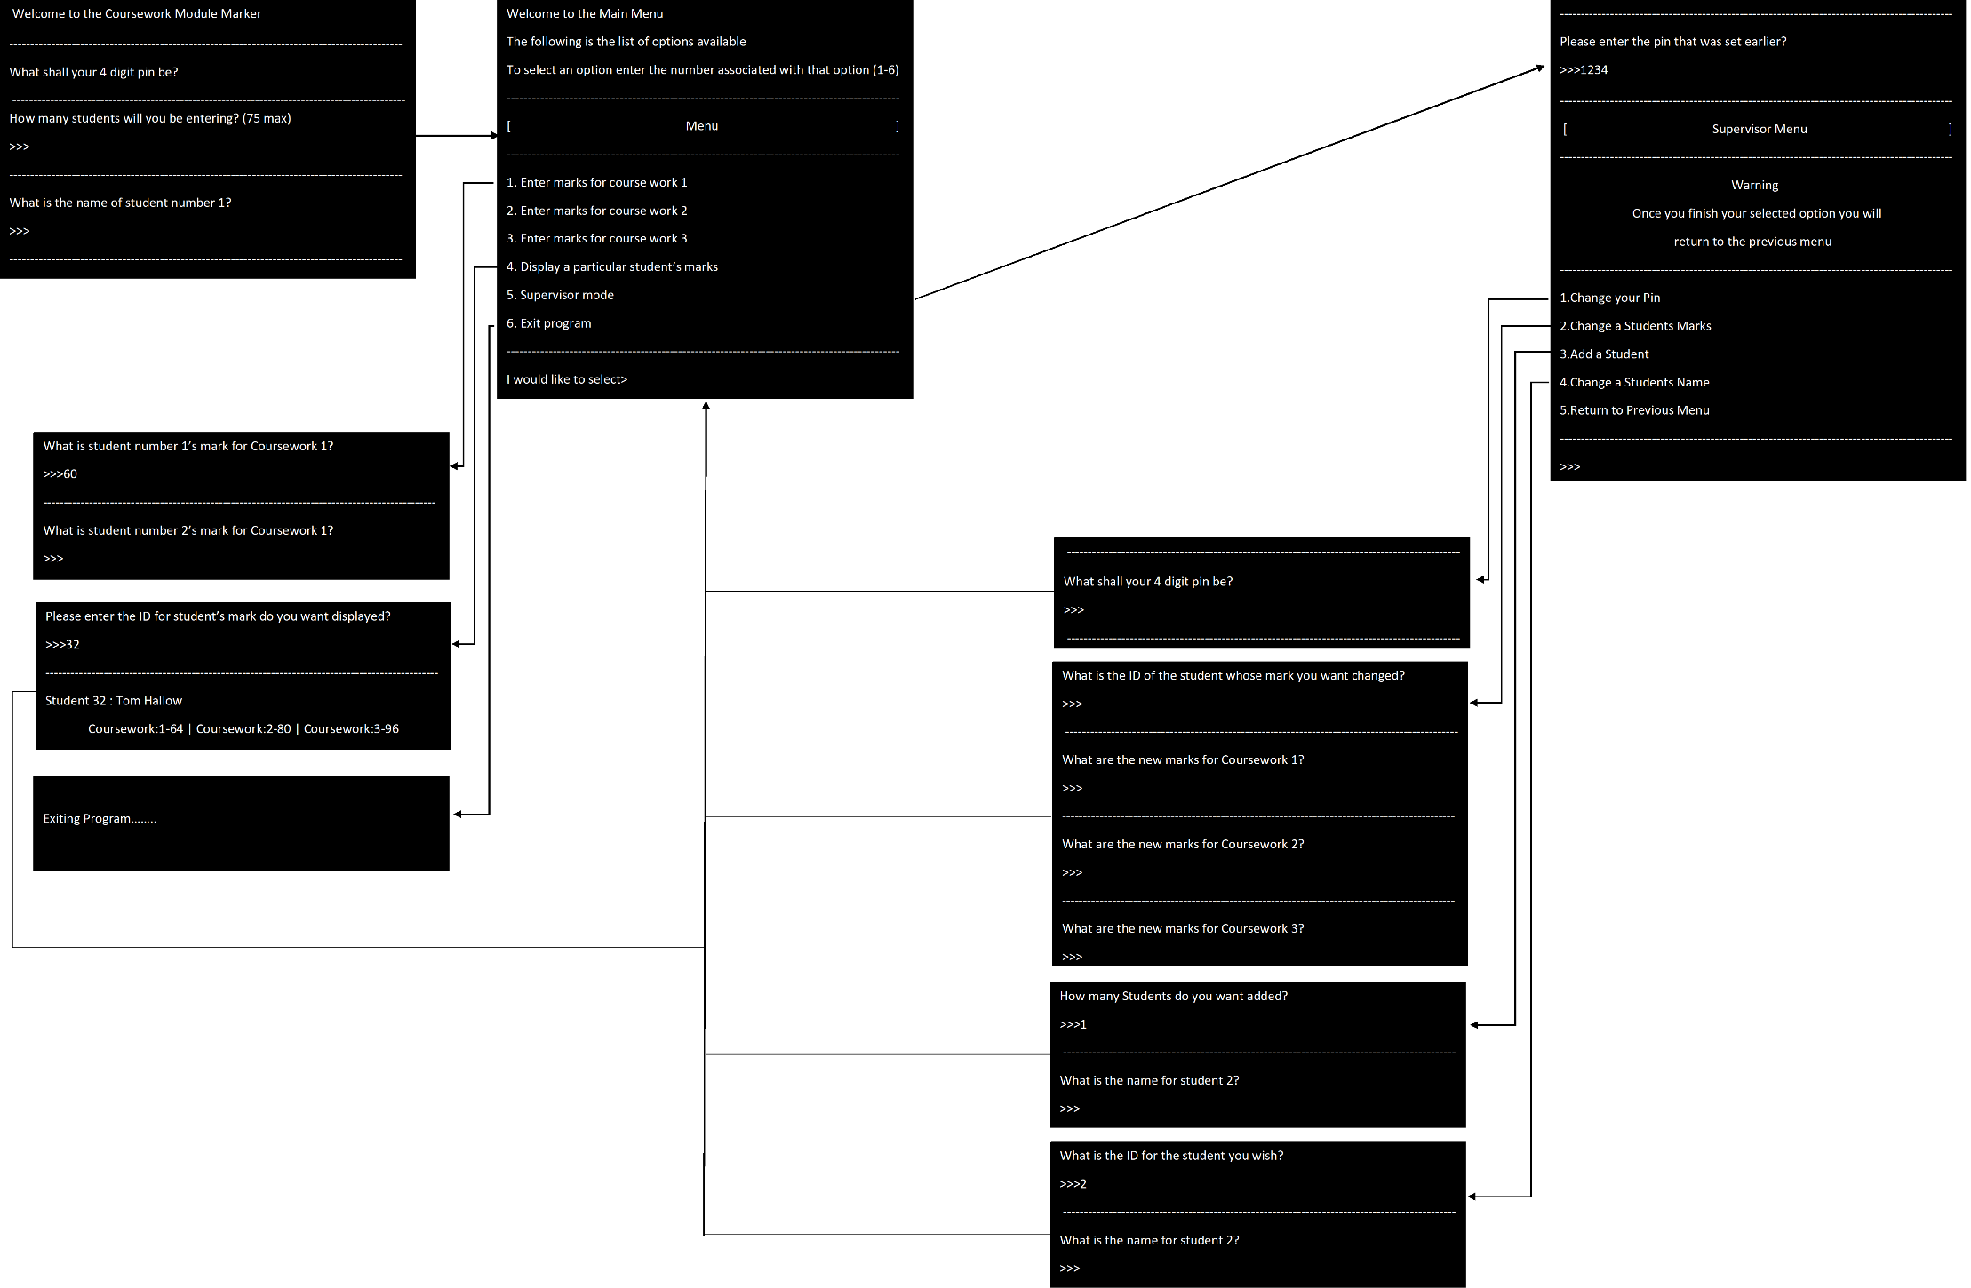

# Pseudo code

## Detail Entry

Number

Print “how many students will you have”=studentNumber

If ID> studentNumber

Print “there is a maximum of ‘studentNumber’ students”

Else

Details Function

Details

While(i<s)

Print “enter student name”=name

For z in name

Student[i][z]

i+1

Options Function

## Main Program

Options

Print “Welcome to the Coursework Module Marker”

Print “The following is the list of options available”

Print “To select an option enter the number associated with that option (1-6)"

Print “1.Enter marks for course work 1”

Print “2.Enter marks for course work 2”

Print “3. Enter marks for course work 3”

Print “4. Display a particular student’s marks”

Print “5. Supervisor mode”

Print “6. Exit program”

Print “I would like to select>”

Choose

Print “What option do you want?”=option

If option = 1

Mark1 Function

If options = 2

Mark2 Function

If option = 3

Mark3 Function

If option = 4

See Student Function

If option = 5

Supervisor Mode Function

If option= 6

Exit Program

Else

Print not a valid option

Choose Function

Mark1 or Mark2 or Mark3 (separate options with similar functions)

Print “What is the marks for the cw”=Value

If Value<101 or Value>-1

Print “Value has to be between 0-100”

Mark1 or Mark2 or Mark3 Function

else

Mark[ID][Cw No.(depends on function no.)]=Value

Print ”Mark has been Entered”

Options Function

See Student

Print ”What is the ID of the student you wish to view”=ID

If ID> studentNumber

Print “there is a maximum of ‘studentNumber’ students”

See Student Function

Else if ID<0

Print “The id is between 0-75”

See Student Function

Print Student[ID][char iterated till void]

Print Mark[ID][iterate0-2]

Module Mark Function

Print “Full Mark”

Print “press enter to return to menu”

Check for enter key

If Enter key pressed

Options Function

Else

Pause

Supervisor Mode

If no pin

Print “enter a new pin”=pin

Save pin to file

Supervisor Options

If pin

Print ”Enter your pin”=pin

Check pin

If correct

Supervisor options

Else

Print ”incorrect pin”

Print “Would you wish to try again”=check

If check=y

Supervisor Mode Function

If check=n

Supervisor Options Function

Supervisor Options

Print “Once your action has been completed you shall be returned to the last menu”

Print supervisor options (Change pin, Change mark, Add Student, Edit Student name, exit supervisor mode)

Supervisor Choose

If option = 1

Change Pin Function

If options = 2

Change Mark Function

If option = 3

Add Student Function

If option = 4

Options function

Else

Supervisor Choose Function

Change pin

Print “enter a new pin”=pin

Save pin to file

Options Function

Change mark

Print “Enter Student ID”=ID

Print “Enter CW no.=CW

Print “Enter New Mark”=New Mark

If New Mark>101 or New mark<0

Print “Value has to be between 0-100”

Change Mark Function

else

Mark[ID][CW]=New Mark

Print ”Mark has been Entered”

Options Function

Add Student

If students<76

Go to next blank row

Print “Student Id =[row number]”

Print ”What is the students name?”=name

Student [Student Id] [iterate through name till void]

Options Function

Else

Print “Max Students reached”

Options Function

Edit Student Name

Print ”What is the students ID?”=ID

Print ”What is the students name?”=name

Student[ID][name iterated till void]

Print “Completed”

Options Function

Exit Supervisor Mode

Options Function

Module Mark

Cw1=Mark[ID][0]

Cw2=Mark[ID][1]

Cw3=Mark[ID][2]

Full Mark=(Cw1*0.2)+(Cw2*0.3)+(Cw3*0.5)

# Screenshots

## Start Screen

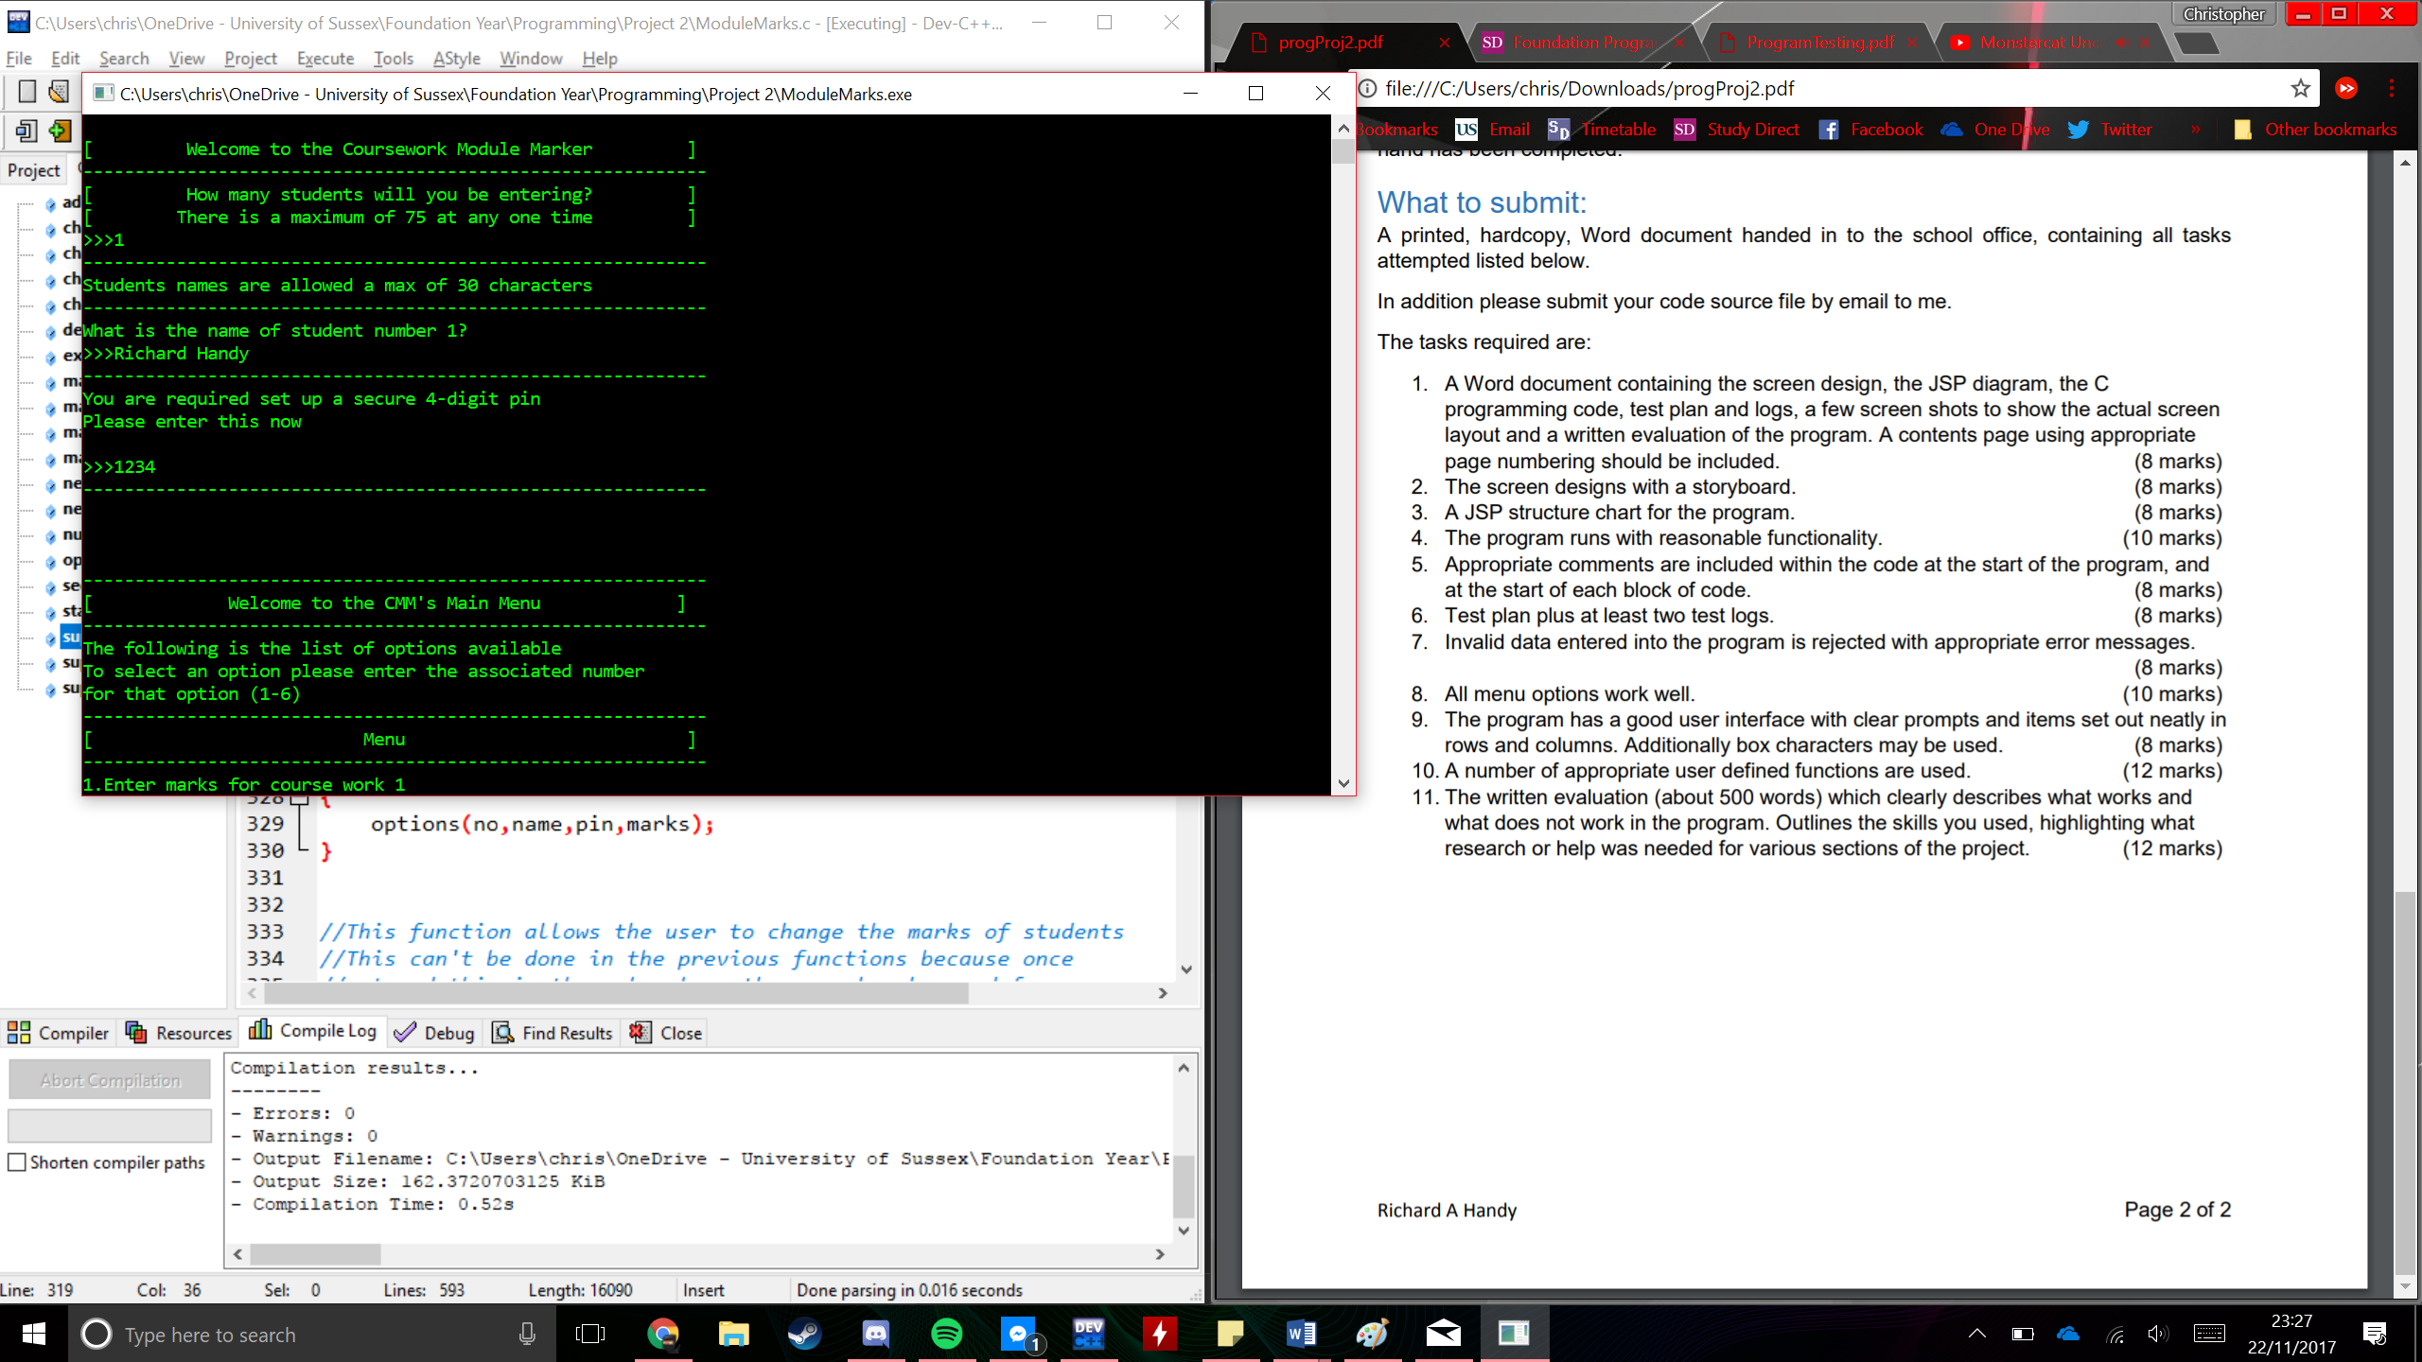

The final start screen is much more organised and better looking than the design and more information is given to the user to assist them with the operation of the screen as well as making the pin the last input of the screen.

## Main Menu

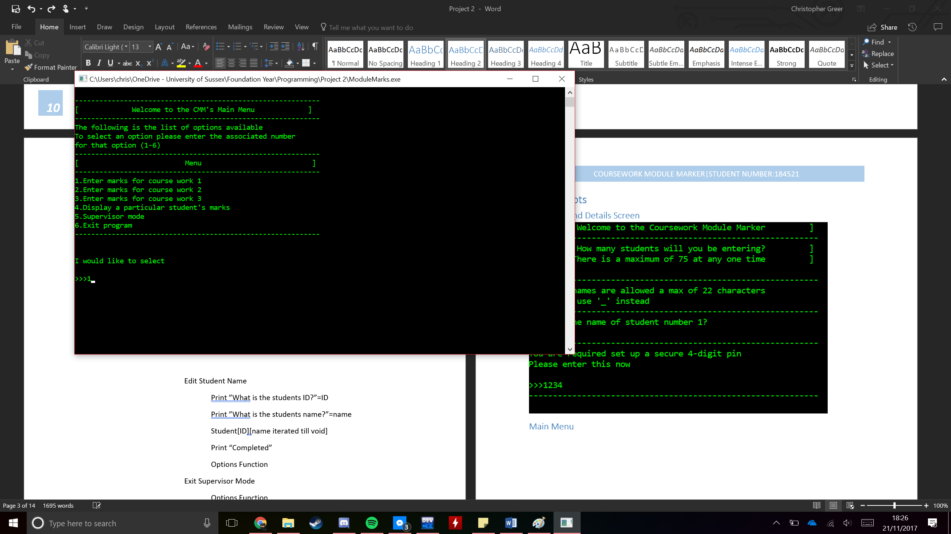

The main menu overall has changed very little as it still contains all the options it was meant to have the only visible change here is the Welcome line at the top has changed and is now centred to give a more professional look.

## Entering Marks Screen (1-3)

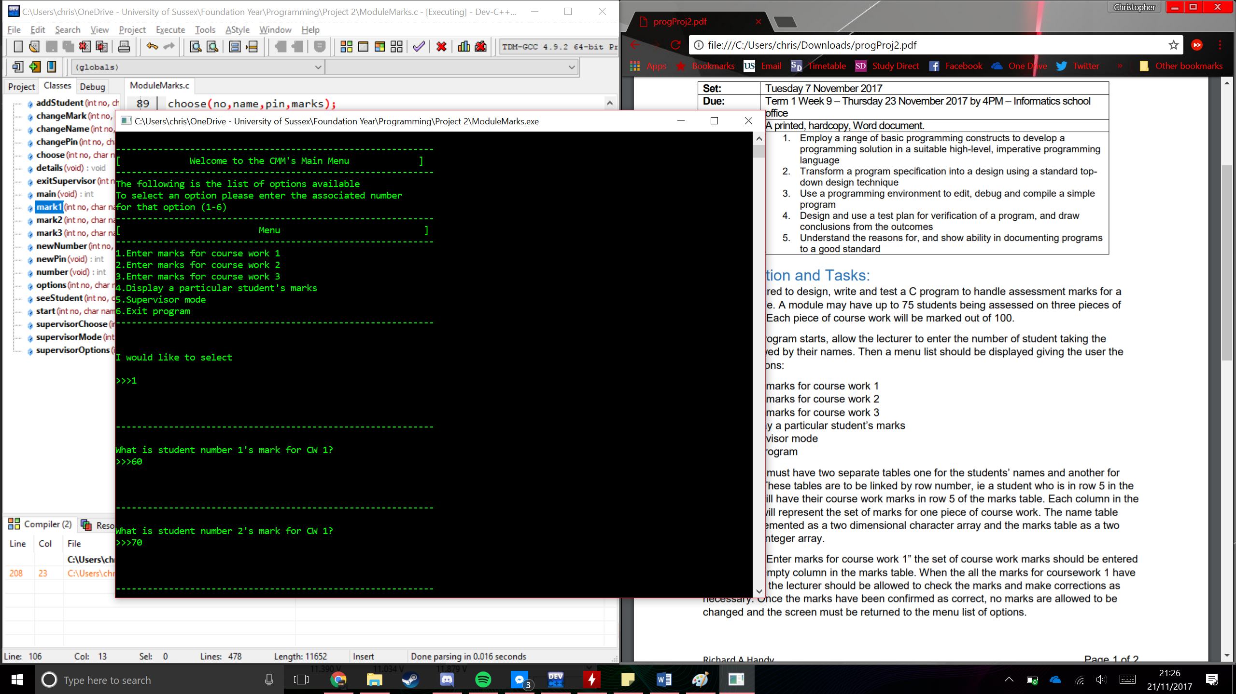

This screenshot shows the entering of marks screen for coursework one which looks almost identical to the other two entering mark screens. The first two lines of code are from the Main menu to show that it is able to go to this screen. The design of this screen hasn’t changed at all and it shall iterate through all of the entered students allowing you to enter all the marks at once.

## Displaying Students Marks Screen

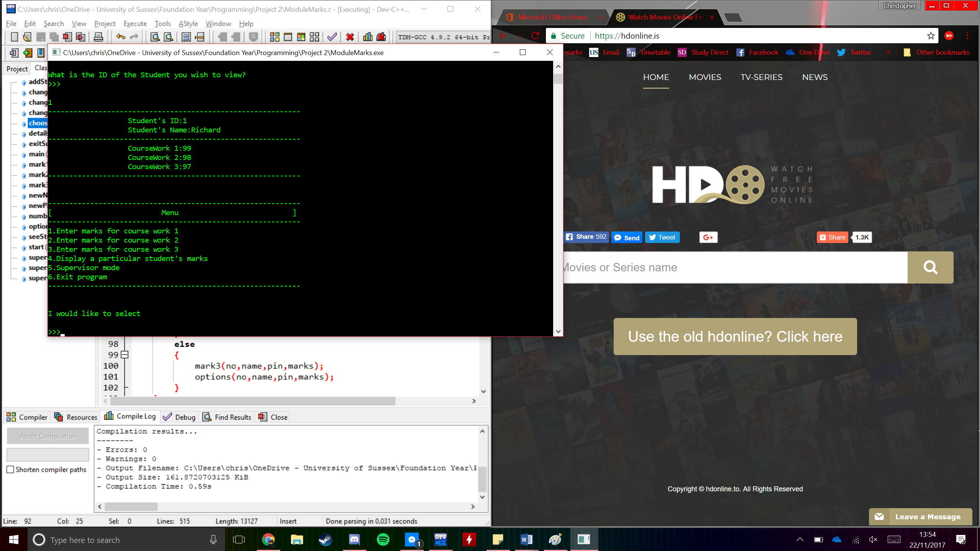

The final implementation of this screen has all the same elements as the design just in a different layout with the ID and name being separate and it all being in one list rather than in separate columns. This is as I believe it makes the program easier to read when the information is displayed.

## Supervisor Mode

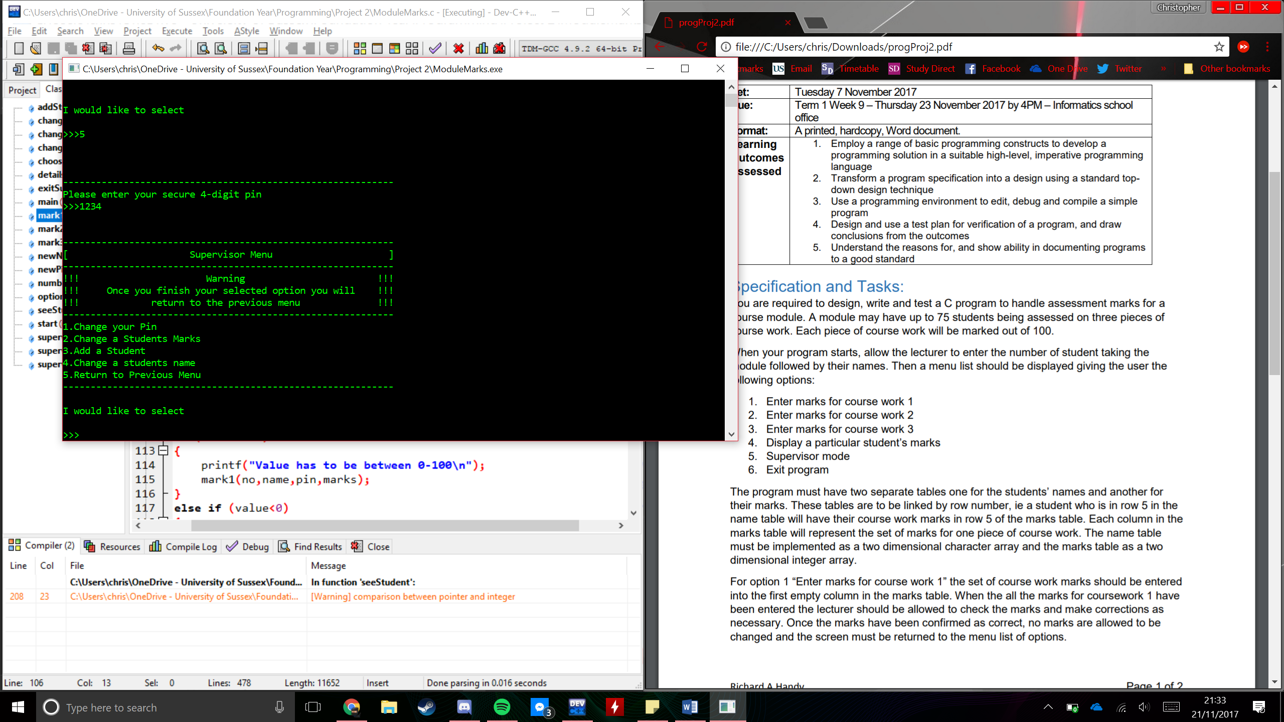

This screenshot displays the supervisor mode/menu which is given to the user when option 5 is selected as shown at the top of the screen. This screen is very similar to its design with all of the displayed options being the same along with it asking for your pin before you enter the menu. The only visible difference here is the warnings having an exclamation mark on either side.

### Change Pin Screen

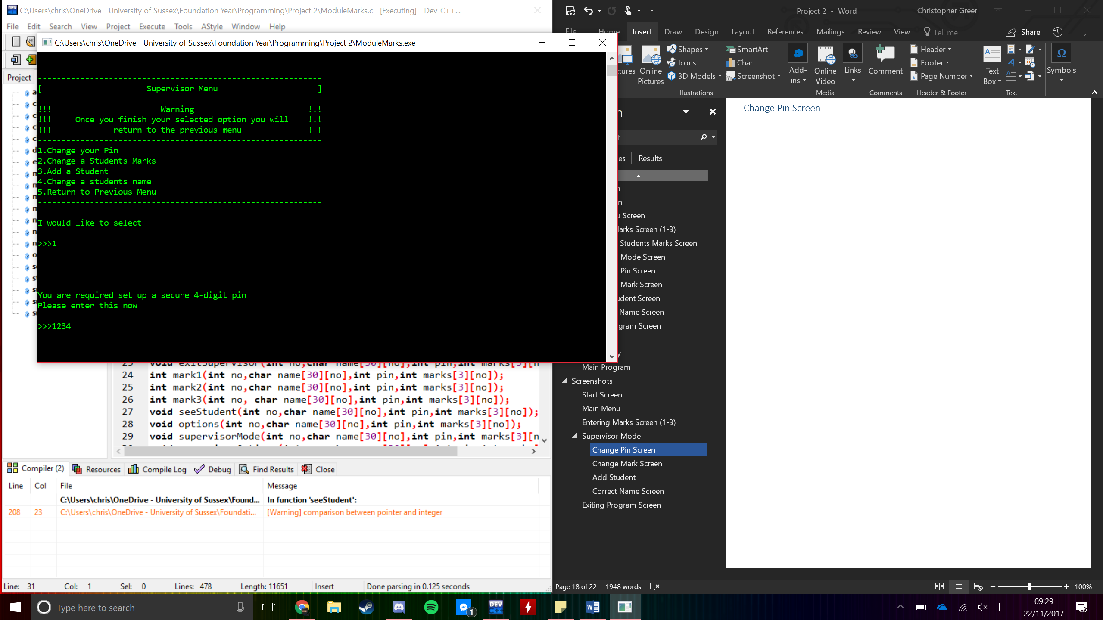

Above is the screenshot for the change pin screen which is shown below the Supervisor Menu has very little difference between it and the original design. This is as it does not require anything fancy other than asking for and getting a simple 4 digit input.

### Change Mark Screen

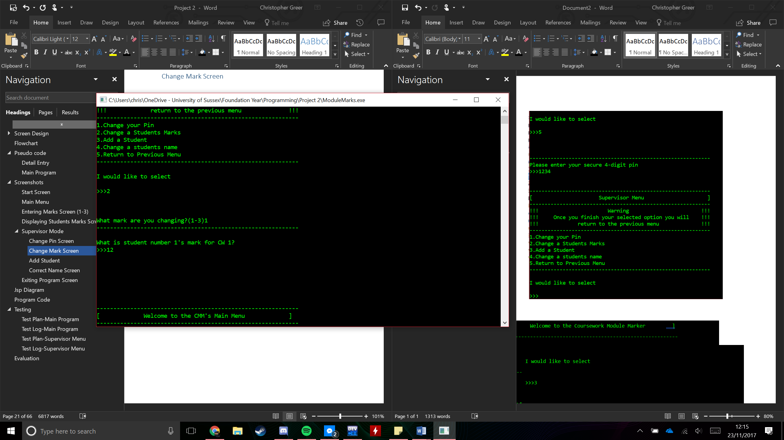

This is showing the supervisor menu at the top where this function is selected. The rest of the screen is the same as the design other than the fact that the user chooses which coursework rather than running through all of them. However there is a major problem with this screen being thatit requires you to enter marks for all of the students not just one.

### Add Student

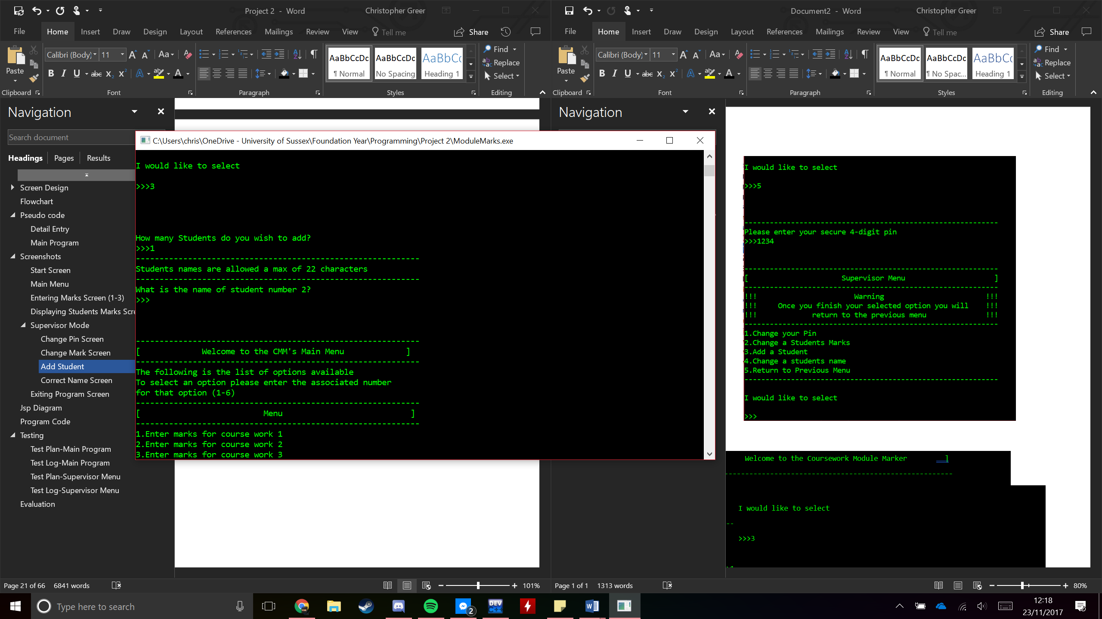

This screenshot shows the add student screen which has changed very little from the original design. Because I started the program by adding one student this means by adding another one the new student will be student number 2 as shown.

### Correct Name Screen

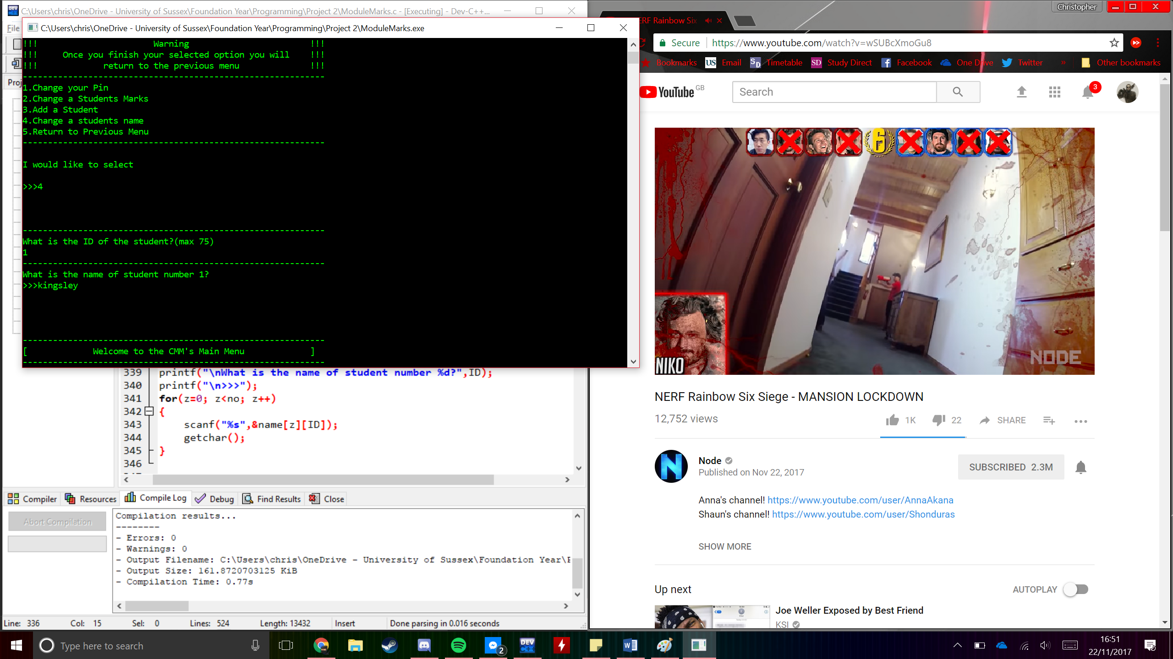

This screen is what is given when the user selects option 4 in the supervisor menu. Overall there are no major changes to this screen from its screen design.

## Exiting Program Screen

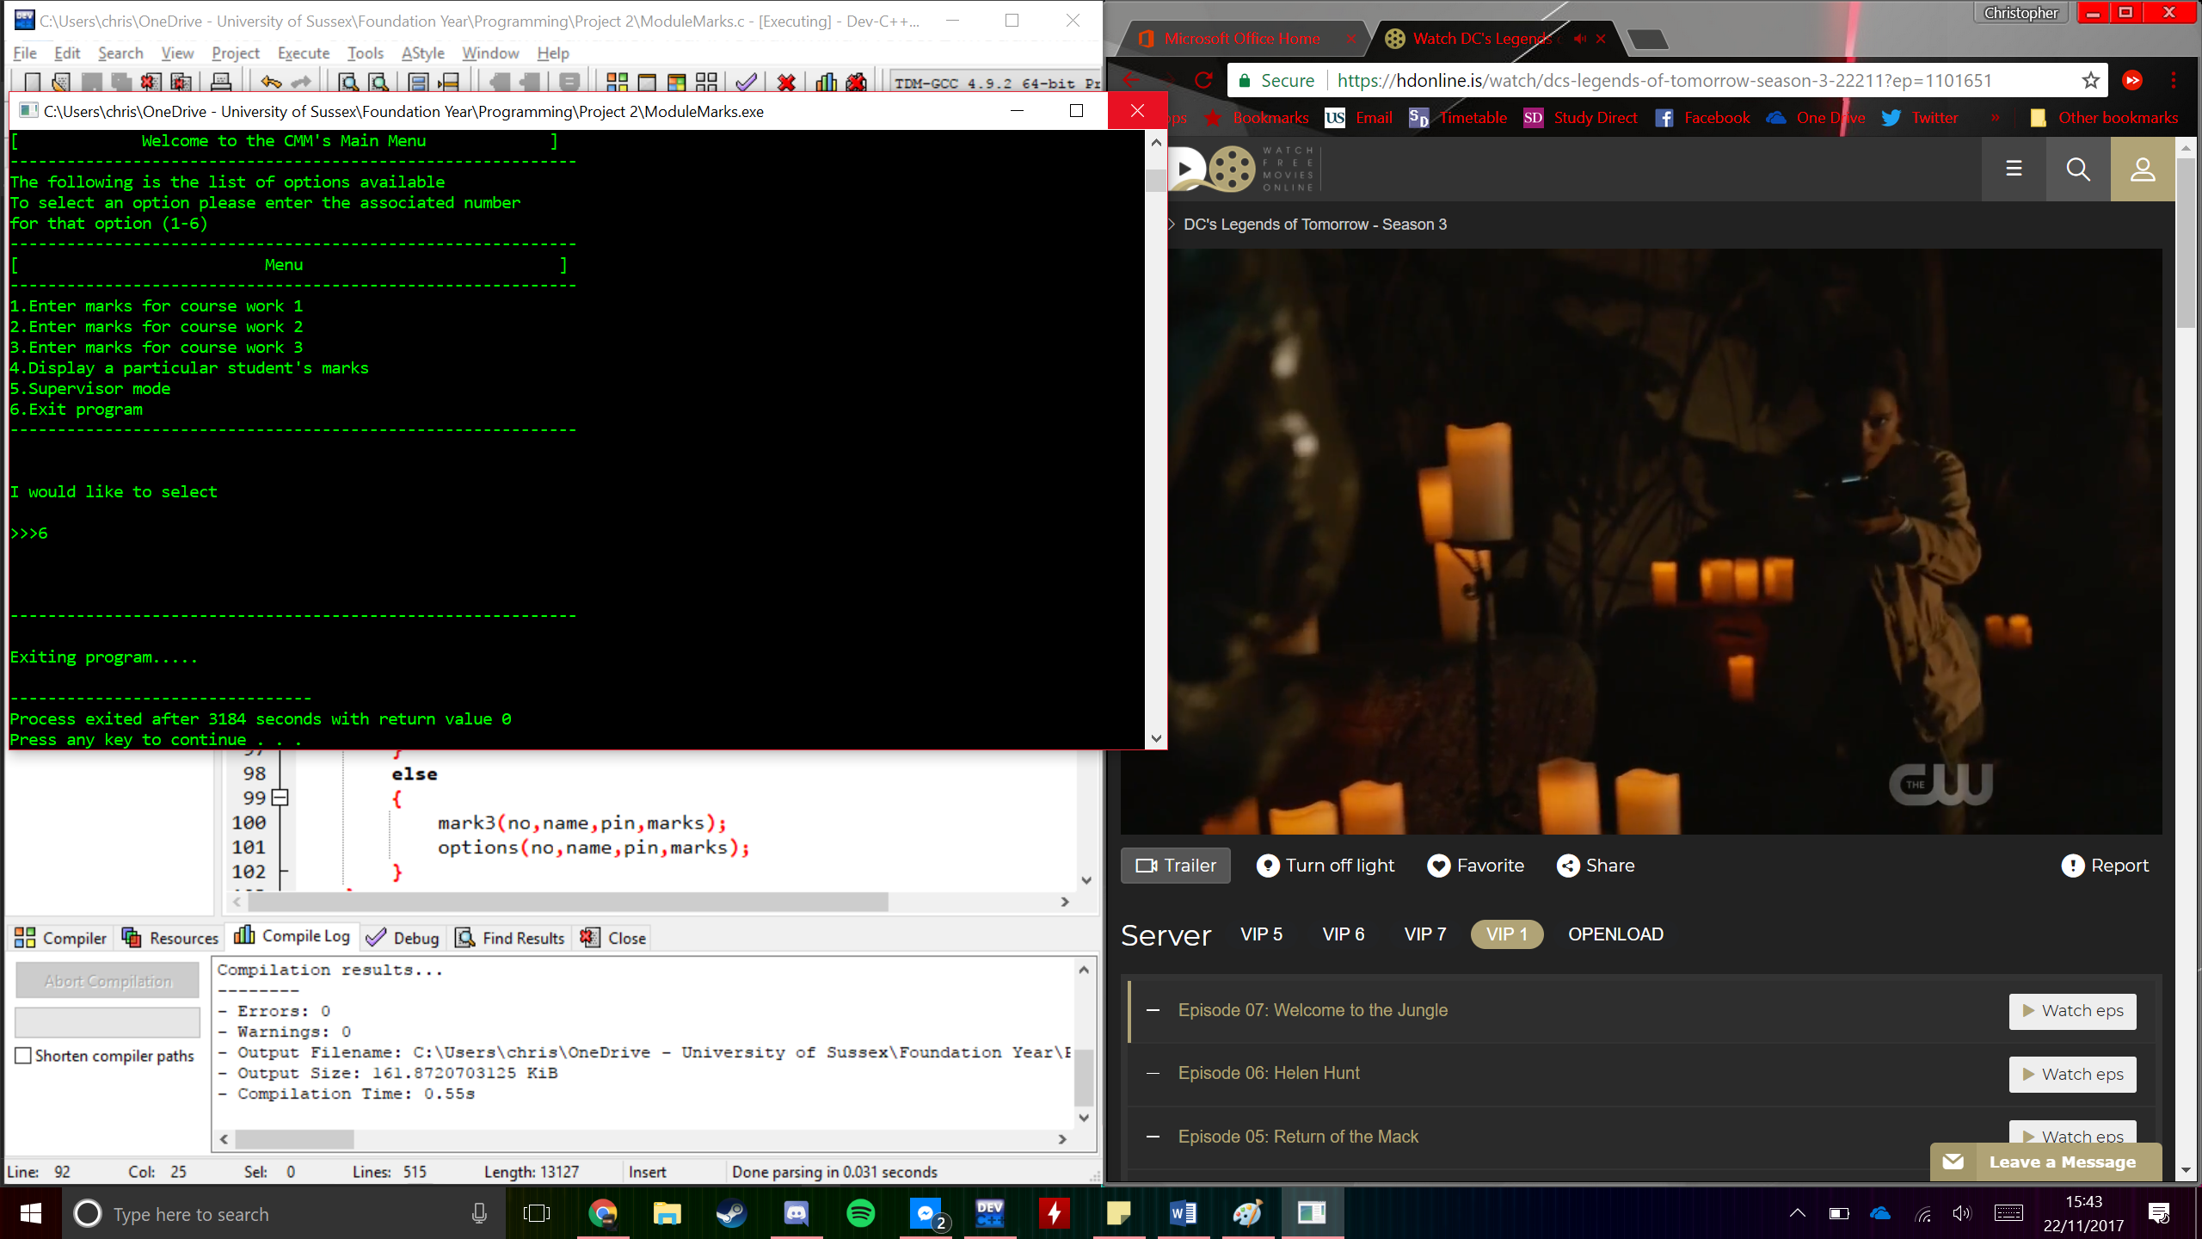

All though a screen is not needed this is the message that is displayed when option 6 of the main menu is clicked this is displayed in the command prompt before the program exits.

# Asp Diagram

ModuleMarks.c

Number

Details

Pin

Options

Mark 1 Mark 2 Mark 3 See Student Supervisor Mode Exit

Options Options Options Options Check Pin

Supervisor options

Change Pins Change marks Add Student Options

Options Options Options

# Program Code

/***********************************************************************

* ModuleMarks.c

* Write a program that displays and handles assessment marks for

* up to 75 students in a course module

* Christopher Greer

* 7th November 2017

* ********************************************************************/

//The following is a list of all of the libraries that have been

//imported to allow the function to run correctly

#include <stdio.h>

#include <stdlib.h>

//This is all of the functions in the code defined at the start

void start(int no, char name[30][no],int pin, int mark[3][no]);

void details(void);

int number(void);

int newPin(void);

void addStudent(int no, char name[30][no],int pin,int newNo);

char changeName(int no,char name[30][no]);

void changeMark(int no,char name[30][no],int pin,int marks[3][no]);

void changePin(int no,char name[30][no], int pin,int marks[3][no]);

int choose(int no,char name[30][no], int pin,int marks[3][no]);

void exitSupervisor(int no,char name[30][no],int pin,int marks[3][no]);

int mark1(int no,char name[30][no],int pin,int marks[3][no]);

int mark2(int no,char name[30][no],int pin,int marks[3][no]);

int mark3(int no, char name[30][no],int pin,int marks[3][no]);

void seeStudent(int no,char name[30][no],int pin,int marks[3][no]);

void options(int no,char name[30][no],int pin,int marks[3][no]);

void supervisorMode(int no,char name[30][no],int pin,int marks[3][no]);

void supervisorOptions(int no, char name[30][no],int pin

,int marks[3][no]);

//This is the function used to print all of the options of the

//main menu

void options(int no,char name[30][no],int pin,int marks[3][no])

{

printf("------------------------------------------------------------");

printf("\n[ Menu ]");

printf("\n------------------------------------------------------------");

printf("\n1.Enter marks for course work 1\n");

printf("2.Enter marks for course work 2\n");

printf("3.Enter marks for course work 3\n");

printf("4.Display a particular student's marks\n");

printf("5.Supervisor mode\n");

printf("6.Exit program\n");

printf("------------------------------------------------------------");

choose(no,name,pin,marks);

}

//This function is used to take the users desired choice from

//the main menu and take them to that screen

int choose(int no, char name[30][no],int pin,int marks[3][no])

{

int option;

printf("\n\n\nI would like to select\n\n>>>");

scanf("%d",&option);

printf("\n\n\n");

if (option==1)

{

if (marks[4][1]==1)

{

printf("------------------------------------------------------------");

printf("\nThese values have already been entered\n");

printf("To change these values go to supervisor menu\n");

printf("------------------------------------------------------------");

options(no,name,pin,marks);

}

else

{

mark1(no,name,pin,marks);

options(no,name,pin,marks);

}

}

else if (option==2)

{

if (marks[4][2]==1)

{

printf("------------------------------------------------------------");

printf("\nThese values have already been entered\n");

printf("To change these values go to supervisor menu\n");

printf("------------------------------------------------------------");

options(no,name,pin,marks);

}

else

{

mark2(no,name,pin,marks);

options(no,name,pin,marks);

}

}

else if (option==3)

{

if (marks[4][3]==1)

{

printf("------------------------------------------------------------");

printf("\nThese values have already been entered\n");

printf("To change these values go to supervisor menu\n");

printf("------------------------------------------------------------");

options(no,name,pin,marks);

}

else

{

mark3(no,name,pin,marks);

options(no,name,pin,marks);

}

}

else if (option==4)

{

seeStudent(no,name,pin,marks);

}

else if (option==5)

{

supervisorMode(no,name,pin,marks);

}

else if (option==6)

{

printf("------------------------------------------------------------");

printf("\n\nExiting program.....\n");

exit(0);

}

else if (option>6)

{

printf("\n\n\n\n Not a valid option");

printf("Must be between 1-6");

choose(no,name,pin,marks);

}

else if (option<1)

{

printf("\n\n\n\n Not a valid option");

printf("Must be between 1-6");

choose(no,name,pin,marks);

}

options(no,name,pin,marks);

}

//This fucntion takes the marks for the first coursework

//for all of the students

int mark1(int no, char name[30][no],int pin,int marks[3][no])

{

int value, ID;

ID=1;

while (ID<(no+1))

{

printf("------------------------------------------------------------");

printf("\n\nWhat is student number %d's mark for CW 1?",ID);

printf("\n>>>");

scanf("%d",&value);

ID=ID+1;

printf("\n\n\n");

if (value>100)

{

printf("Value has to be between 0-100\n");

mark1(no,name,pin,marks);

}

else if (value<0)

{

printf("Value has to be between 0-100\n");

mark1(no,name,pin,marks);

}

else

{

marks[4][1]=1;

marks[1][ID]=value;

}

}

return marks[1][ID];

}

//This function takes the marks for the second coursework

//for all of the students

int mark2(int no,char name[30][no],int pin,int marks[3][no])

{

int value, ID;

ID=1;

while (ID<(no+1))

{

printf("\nWhat is student number %d's mark for CW 2?",ID);

printf("\n>>>");

scanf("%d",&value);

ID=ID+1;

printf("\n\n\n");

if (value>100)

{

printf("Value has to be between 0-100\n");

mark2(no,name,pin,marks);

}

else if (value<0)

{

printf("Value has to be between 0-100\n");

mark2(no,name,pin,marks);

}

else

{

marks[4][2]=1;

marks[2][ID]=value;

}

}

return marks[2][ID];

}

//This fucntion takes the marks for the third coursework

//for all of the students

int mark3(int no,char name[30][no],int pin,int marks[3][no])

{

int value, ID;

ID=1;

while (ID<(no+1))

{

printf("\nWhat is student number %d's mark for CW 3?",ID);

printf("\n>>>");

scanf("%d",&value);

ID=ID+1;

printf("\n\n\n");

if (value>100)

{

printf("Value has to be between 0-100\n");

mark3(no,name,pin,marks);

}

else if (value<0)

{

printf("Value has to be between 0-100\n");

mark3(no,name,pin,marks);

}

else

{

marks[4][3]=1;

marks[3][ID]=value;

}

}

return marks[3][ID];

}

//This function is used to look at a students name and marks

//and have them displayed in professional format

void seeStudent(int no,char name[30][no],int pin,int marks[3][no])

{

int ID,z;

printf("What is the ID of the Student you wish to view?");

printf("\n>>>\n\n");

scanf("%d",&ID);

if (ID>no)

{

printf("There is a maximum of %d students\n",no);

seeStudent(no,name,pin,marks);

}

else if (ID<0)

{

printf("The id is between 0-%d\n",no);

seeStudent(no,name,pin,marks);

}

else

{

printf("------------------------------------------------------------");

printf("\n Student's ID:%d",ID);

printf("\n Student's Name:%s \n", &name[0][ID]);

printf("------------------------------------------------------------");

printf("\n CourseWork 1:%d",marks[1][ID]);

printf("\n CourseWork 2:%d",marks[2][ID]);

printf("\n CourseWork 3:%d\n",marks[3][ID]);

printf("------------------------------------------------------------");

printf("\n\n\n");

}

options(no,name,pin,marks);

}

//This is the function that allows the user to choose options from the

//supervisor menu hence why it has a similar name to the choosing function

// of the main menu

void supervisorChoose(int no, char name[30][no],int pin,int marks[3][no])

{

int option,newNo;

printf("\nI would like to select\n\n>>>");

scanf("%d",&option);

printf("\n\n\n");

if (option==1)

{

pin=newPin();

start(no,name,pin,marks);

}

else if (option==2)

{

changeMark(no,name,pin,marks);

start(no,name,pin,marks);

}

else if (option==3)

{

newNo=newNumber(no,name,pin);

addStudent(no,name,pin,newNo);

no=newNo;

start(no,name,pin,marks);

}

else if (option==4)

{

changeName(no,name);

start(no,name,pin,marks);

}

else if (option==5)

{

start(no,name,pin,marks);

}

else if (option>5)

{

printf("\n\n\n\n Not a valid option");

printf("Must be between 1-5");

supervisorChoose(no,name,pin,marks);

}

else if (option<1)

{

printf("\n\n\n\n Not a valid option");

printf("Must be between 1-5");

supervisorChoose(no,name,pin,marks);

};

}

//This function allows the user to change their previously

//entered pin to something different

void changePin(int no, char name[30][no],int pin,int marks[3][no])

{

options(no,name,pin,marks);

}

//This function allows the user to change the marks of students

//This can't be done in the previous functions because once

//entered this is the only place they can be chnanged from

void changeMark(int no,char name[30][no],int pin,int marks[3][no])

{

int option;

printf("What mark are you changing?(1-3)");

scanf("%d",&option);

if (option==1)

{

mark1(no,name,pin,marks);

}

else if (option==2)

{

mark2(no,name,pin,marks);

}

else if (option==3)

{

mark3(no,name,pin,marks);

}

else

{

printf("Selection must be between 1 and 3");

changeMark(no,name,pin,marks);

}

}

//This function allows the changing of a students name

char changeName(int no, char name[30][no])

{

int ID,z;

printf("------------------------------------------------------------");

printf("\nWhat is the ID of the student?(max 75)\n");

scanf("%d",&ID);

printf("------------------------------------------------------------");

printf("\nWhat is the name of student number %d?",ID);

printf("\n>>>");

for(z=0; z<no; z++)

{

scanf("%s",&name[z][ID]);

getchar();

}

}

//This function is required in the adding of a new student

//This is as it is used to get the new tital number of

//students located in the array

int newNumber(int no,char name[30][no],int pin)

{

int newNo,in;

printf("\nHow many Students do you wish to add?\n");

printf(">>>");

scanf("%d",&in);

if ((in+no)>75)

{

printf("Maximum of 75 students allowed\n");

printf("Entering %d will give you %d students\n",in,(in+no));

newNumber(no,name, pin);

}

else if(in<0)

{

printf("You can't remove students'\n");

newNumber(no,name, pin);

}

else

{

newNo=no+in;

return newNo;

}

}

//This fucntion uses the output of the last function to add the required

//number of new students to the array

void addStudent(int no,char name[30][no],int pin,int newNo)

{

int i,z;

printf("------------------------------------------------------------");

i=no+1;

z=0;

printf("\nStudents names are allowed a max of 22 characters\n");

printf("------------------------------------------------------------");

while (i<((newNo)+1))

{

printf("\nWhat is the name of student number %d?",i);

printf("\n>>>");

for(z=0; z<no; z++)

scanf("%[^\n]",&name[z][i]);

getchar();

i=i+1;

}

no=newNo;

}

//This function exits the user from the supervisor menu and back

//to the main menu

void exitSupervisor(int no,char name[30][no],int pin,int marks[3][no])

{

options(no,name,pin,marks);

}

void supervisorOptions(int no,char name[30][no],int pin,int marks[3][no])

{

printf("\n\n");

printf("------------------------------------------------------------\n");

printf("[ Supervisor Menu ]\n");

printf("------------------------------------------------------------\n");

printf("!!! Warning !!!\n");

printf("!!! Once you finish your selected option you will !!!\n");

printf("!!! return to the previous menu !!!\n");

printf("------------------------------------------------------------\n");

printf("1.Change your Pin\n");

printf("2.Change a Students Marks\n");

printf("3.Add a Student\n");

printf("4.Change a students name\n");

printf("5.Return to Previous Menu\n");

printf("------------------------------------------------------------\n");

supervisorChoose(no,name,pin,marks);

}

//This function is used to take in a pin and if correct shall

//take them to the supervisor menu, if it is not it shall ask

//ask them if they wish to retry if not they'll be returned

//to the main menu

void supervisorMode(int no,char name[30][no],int pin,int marks[3][no])

{

int enteredPin,z;

printf("------------------------------------------------------------");

printf("\nPlease enter your secure 4-digit pin");

printf("\n>>>");

scanf("%d",&enteredPin);

if (enteredPin==pin)

{

supervisorOptions(no,name,pin,marks);

}

else

{

char o[0];

printf("\nYou have entered the wrong pin");

printf("\nDo you wish to try again?");

printf("\ny or n");

printf("\n>>>");

scanf("%s",&o[0]);

getchar();

if (o[0]=='y')

{

supervisorMode(no, name, pin,marks);

}

else

{

options(no,name,pin,marks);

}

}

}

//This fucntion is used towards the start of the program to get the total

//number of students that will be in the array

int number(void)

{

int no,i;

i=1;

printf("\n[ Welcome to the Coursework Module Marker ]\n");

printf("------------------------------------------------------------");

printf("\n[ How many students will you be entering? ]");

printf("\n[ There is a maximum of 75 at any one time ]");

printf("\n>>>");

scanf("%d",&no);

getchar();

printf("------------------------------------------------------------");

if (no>75)

{

printf("\nNumber of students is 75 max\n");

printf("------------------------------------------------------------");

number();

}

else if (no<1)

{

printf("\nNumber of students is between 1-75\n");

printf("------------------------------------------------------------");

number();

}

return no;

}

//This fucntion is used to get the pin from the user

//This shall be used to gain access to the supervisor menu

int newPin(void)

{

int pin;

printf("------------------------------------------------------------");

printf("\nYou are required set up a secure 4-digit pin\n");

printf("Please enter this now\n");

printf("\n>>>");

scanf("%d",&pin);

if (pin>9999)

{

printf("Must be a 4 digit pin\n");

newPin();

}

return pin;

}

//This function is used to collect the details of the students

void details(void)

{

int no,i,z,pin,marks[3][no];

char name[30][no];

no=number();

i=1;

z=0;

printf("\nStudents names are allowed a max of 30 characters\n");

printf("------------------------------------------------------------");

while (i<(no+1))

{

printf("\nWhat is the name of student number %d?",i);

printf("\n>>>");

for(z=0; z<no; z++)

scanf("%[^\n]",&name[z][i]);

getchar();

i=i+1;

}

pin=newPin();

printf("------------------------------------------------------------");

start(no,name,pin,marks);

}

//This function is used to welcome the user to the main menu

//and give them appropriate information on how to use it

void start(int no, char name[30][no],int pin,int marks[3][no])

{

printf("\n\n\n\n");

printf("------------------------------------------------------------");

printf("\n[ Welcome to the CMM's Main Menu ]\n");

printf("------------------------------------------------------------");

printf("\nThe following is the list of options available\n");

printf("To select an option please enter the associated number");

printf("\nfor that option (1-6)\n");

options(no,name,pin,marks);

}

//This is the main function of the program which is used to

//run the details function and start the program

int main(void)

{

details();

return 0;

}

# Testing

The following are testing plans to show what happens in the program when incorrect values are entered into the system and the upper and lower boundaries of the expected inputs. For all of the test logs step 1 are straight copy and pastes directly from the interface whereas the steps that follow are simple screenshots of the interface.

## Test Plan-Main Program

|  |  |  |  |
| --- | --- | --- | --- |
| Step | Input Data | Expected Output | Comment |
| 1 | Student Number:5  Names:  Richard Handy  Ramiz Alihodzic  Kingsley Sage  Fred Jones  Graham Smith  Pin: 1234  Select:1  Marks for CW1:  46  54  97  78  76  Select:2  Marks for CW2:  83  84  47  74  48  Select:3  Marks for CW3:  46  54  97  78  76  Select:4  1  Select:4  2  Select:4  3  Select:4  4  Select:4  5 | [ How many students will you be entering? ]  [ There is a maximum of 75 at any one time ]  >>>5  What is the name of student number 1?  >>>Richard_Handy  What is the name of student number 2?  >>> Ramiz_Alihodzic  What is the name of student number 3?  >>> Kingsley_Sage  What is the name of student number 4?  >>> Fred_Jones  What is the name of student number 5?  >>> Graham_Smith  You are required set up a secure 4-digit pin  Please enter this now  >>>1234  I would like to select  >>>1  What is student number 1's mark for CW 1?  >>>46  What is student number 1's mark for CW 1?  >>>54  What is student number 1's mark for CW 1?  >>>97  What is student number 1's mark for CW 1?  >>>78  What is student number 1's mark for CW 1?  >>>76  I would like to select  >>>2  What is student number 1's mark for CW 2?  >>>83  What is student number 1's mark for CW 2?  >>>84  What is student number 1's mark for CW 2?  >>>47  What is student number 1's mark for CW 2?  >>>74  What is student number 1's mark for CW 2?  >>>48  I would like to select  >>>3  What is student number 1's mark for CW 33?  >>>46  What is student number 1's mark for CW 3?  >>>54  What is student number 1's mark for CW 3?  >>>97  What is student number 1's mark for CW 3?  >>>78  What is student number 1's mark for CW 3?  >>>76  I would like to select  >>>4  What is the ID of the Student you wish to view?  >>>1  ------------------------------------------------------------  Student's ID:1  Student's Name:Richard Handy  ------------------------------------------------------------  CourseWork 1:46  CourseWork 2:83  CourseWork 3:46  I would like to select  >>>4  What is the ID of the Student you wish to view?  >>>2  ------------------------------------------------------------  Student's ID:1  Student's Name: Ramiz Alihodzic  ------------------------------------------------------------  CourseWork 1:54  CourseWork 2:84  CourseWork 3:54  ------------------------------------------------------------  I would like to select  >>>4  What is the ID of the Student you wish to view?  >>>3  ------------------------------------------------------------  Student's ID:1  Student's Name:Kingsley Sage  ------------------------------------------------------------  CourseWork 1:97  CourseWork 2:47  CourseWork 3:97  I would like to select  >>>4  What is the ID of the Student you wish to view?  >>>4  ------------------------------------------------------------  Student's ID:1  Student's Name:Fred Jones  ------------------------------------------------------------  CourseWork 1:78  CourseWork 2:74  CourseWork 3:78  I would like to select  >>>4  What is the ID of the Student you wish to view?  >>>5  ------------------------------------------------------------  Student's ID:1  Student's Name:Graham Smith  ------------------------------------------------------------  CourseWork 1:97  CourseWork 2:47  CourseWork 3:97 | Simple test data that would usually be entered |
| 2 | Number of Students: 0 | Number of students is between 1-75 | Lower Boundary |
| 3 | Number of Students: 76 | Number of students is 75 max | Upper Boundary |
| 4 | Option: 0 | Not a valid option | Lower Boundary |
| 5 | Option: 7 | Not a valid option | Upper Boundary |
| 6 | Marks: -1 | Marks are between 0-100 | Lower Boundary |
| 7 | Marks: 101 | Marks are between 0-100 | Upper Boundary |
| 8 | Marks:56  Select:1 | These values have already been entered | Re-entering of data |

## Test Log-Main Program

|  |  |  |
| --- | --- | --- |
| Step | Actual Output | Comment |
| 1 | [ Welcome to the Coursework Module Marker ]  ------------------------------------------------------------  [ How many students will you be entering? ]  [ There is a maximum of 75 at any one time ]  >>>5  ----------------------------------------------------------  Students names are allowed a max of 30 characters  ----------------------------------------------------------  What is the name of student number 1?  >>>Richard Handy  What is the name of student number 2?  >>>Ramiz Alihodzic  What is the name of student number 3?  >>>Kingsley Sage  What is the name of student number 4?  >>>Fred Jones  What is the name of student number 5?  >>>Graham Smith  ----------------------------------------------------------  You are required set up a secure 4-digit pin  Please enter this now  >>>1234  ----------------------------------------------------------  ---------------------------------------------------------  [ Welcome to the CMM's Main Menu ]  ----------------------------------------------------------  The following is the list of options available  To select an option please enter the associated number  for that option (1-6)  ----------------------------------------------------------  [ Menu ]  ----------------------------------------------------------  1.Enter marks for course work 1  2.Enter marks for course work 2  3.Enter marks for course work 3  4.Display a particular student's marks  5.Supervisor mode  6.Exit program  ----------------------------------------------------------  I would like to select  >>>1  ----------------------------------------------------------  What is student number 1's mark for CW 1?  >>>46  ----------------------------------------------------------  What is student number 2's mark for CW 1?  >>>54  ----------------------------------------------------------  What is student number 3's mark for CW 1?  >>>97  ----------------------------------------------------------  What is student number 4's mark for CW 1?  >>>78  ----------------------------------------------------------  What is student number 5's mark for CW 1?  >>>76  ----------------------------------------------------------  [ Menu ]  ------------------------------------------------------------  1.Enter marks for course work 1  2.Enter marks for course work 2  3.Enter marks for course work 3  4.Display a particular student's marks  5.Supervisor mode  6.Exit program  ----------------------------------------------------------  I would like to select  >>>2  What is student number 1's mark for CW 2?  >>>83  What is student number 2's mark for CW 2?  >>>84  What is student number 3's mark for CW 2?  >>>47  What is student number 4's mark for CW 2?  >>>74  What is student number 5's mark for CW 2?  >>>48  ----------------------------------------------------------  [ Menu ]  ----------------------------------------------------------  1.Enter marks for course work 1  2.Enter marks for course work 2  3.Enter marks for course work 3  4.Display a particular student's marks  5.Supervisor mode  6.Exit program  ----------------------------------------------------------  I would like to select  >>>3  What is student number 1's mark for CW 3?  >>>46  What is student number 2's mark for CW 3?  >>>54  What is student number 3's mark for CW 3?  >>>97  What is student number 4's mark for CW 3?  >>>78  What is student number 5's mark for CW 3?  >>>76  ----------------------------------------------------------  [ Menu ]  ----------------------------------------------------------  1.Enter marks for course work 1  2.Enter marks for course work 2  3.Enter marks for course work 3  4.Display a particular student's marks  5.Supervisor mode  6.Exit program  ----------------------------------------------------------  I would like to select  >>>4  What is the ID of the Student you wish to view?  >>>1  ------------------------------------------------------------  Student's ID:1  Student's Name:Richard Handy  ------------------------------------------------------------  CourseWork 1:46  CourseWork 2:83  CourseWork 3:46  I would like to select  >>>4  What is the ID of the Student you wish to view?  >>>2  ------------------------------------------------------------  Student's ID:1  Student's Name: Ramiz Alihodzic  ------------------------------------------------------------  CourseWork 1:54  CourseWork 2:84  CourseWork 3:54  ------------------------------------------------------------  I would like to select  >>>4  What is the ID of the Student you wish to view?  >>>3  ------------------------------------------------------------  Student's ID:1  Student's Name:Kingsley Sage  ------------------------------------------------------------  CourseWork 1:97  CourseWork 2:47  CourseWork 3:97  I would like to select  >>>4  What is the ID of the Student you wish to view?  >>>4  ------------------------------------------------------------  Student's ID:1  Student's Name:Fred Jones  ------------------------------------------------------------  CourseWork 1:78  CourseWork 2:74  CourseWork 3:78  I would like to select  >>>4  What is the ID of the Student you wish to view?  >>>5  ------------------------------------------------------------  Student's ID:1  Student's Name:Graham Smith  ------------------------------------------------------------  CourseWork 1:97  CourseWork 2:47  CourseWork 3:97 | Good |
| 2 |  | Correct |
| 3 |  | Correct |
| 4 |  | Correct |
| 5 |  | Correct |
| 6 |  | Correct |
| 7 |  | Correct |
| 8 |  | Correct other than display error on last line |

## Test Plan-Supervisor Menu

|  |  |  |  |
| --- | --- | --- | --- |
| Step | Input Data | Expected Output | Comment |
| 1 | Student Number:5  Names:  Richard Handy  Ramiz Alihodzic  Kingsley Sage  Fred Jones  Graham Smith  Pin: 1234  Select:1  Marks for CW1:  46  Select:2  Marks for CW2:  83  Select:3  Marks for CW3:  46  Select:5  Pin:1234  Select:1  New pin:5678  Select:5  Pin:5678  Select:2  Change:1  Mark:23  Select:5  Pin:5678  Select:3  Student Number:1  Name: Ramiz Alihodzic  Select:5  Pin:5678  Select:4  ID:1  Name:Kingsley | [ How many students will you be entering? ]  [ There is a maximum of 75 at any one time ]  >>>5  What is the name of student number 1?  >>>Richard_Handy  You are required set up a secure 4-digit pin  Please enter this now  >>>1234  I would like to select  >>>1  What is student number 1's mark for CW 1?  >>>46  I would like to select  >>>2  What is student number 1's mark for CW 2?  >>>83  I would like to select  >>>3  What is student number 1's mark for CW 3?  >>>46  I would like to select  >>>5  Please enter your secure 4-digit pin  >>>1234  I would like to select  >>>1  Please enter your secure 4-digit pin  >>>5678  I would like to select  >>>5  Please enter your secure 4-digit pin  >>>5678  I would like to select  >>>2  What mark are you changing?(1-3)  >>>1  What is student number 1's mark for CW 1?  >>>23  I would like to select  >>>5  Please enter your secure 4-digit pin  >>>5678  I would like to select  >>>3  How many Students do you wish to add?  >>>1  What is the name of student number2?  >>> Ramiz Alihodzic  I would like to select  >>>5  Please enter your secure 4-digit pin  >>>5678  I would like to select  >>>4  What is the ID of the student?  >>>1  What is the name of student number 1?  >>>Kingsley | Simple test data that would usually be entered |
| 2 | Pin: 21345 | Must be a 4-digit pin | Incorrect Value |
| 3 | Pin:1234  Pin Entered: 5678 | Wrong Pin was entered  Would you like to try again  >>>y  Please enter your pin  >>> | Incorrect Value |
| 4 | Option: 0 | Not a valid option | Lower Boundary |
| 5 | Option: 6 | Not a valid option | Upper Boundary |
| 6 | Marks: -1 | Marks are between 0-100 | Lower Boundary |
| 7 | Marks: 101 | Marks are between 0-100 | Upper Boundary |
| 8 | Students: 1  New Students:-1 | Number of new students must be between 1-74 | Lower Boundary |
| 9 | Students:1  New Students:75 | Number of new students must be between 1-74 | Upper Boundary |

## Test Log-Supervisor Menu

|  |  |  |
| --- | --- | --- |
| Step | Actual Output | Comment |
| 1 | [ Welcome to the Coursework Module Marker ]  ----------------------------------------------------------  [ How many students will you be entering? ]  [ There is a maximum of 75 at any one time ]  >>>1  ----------------------------------------------------------  Students names are allowed a max of 30 characters  ----------------------------------------------------------  What is the name of student number 1?  >>>Richard Handy  ----------------------------------------------------------  You are required set up a secure 4-digit pin  Please enter this now  >>>1234  ----------------------------------------------------------  ----------------------------------------------------------  [ Welcome to the CMM's Main Menu ]  ---------------------------------------------------------  The following is the list of options available  To select an option please enter the associated number  for that option (1-6)  ----------------------------------------------------------  [ Menu ]  ----------------------------------------------------------  1.Enter marks for course work 1  2.Enter marks for course work 2  3.Enter marks for course work 3  4.Display a particular student's marks  5.Supervisor mode  6.Exit program  ----------------------------------------------------------  I would like to select  >>>5  ----------------------------------------------------------  Please enter your secure 4-digit pin  >>>1234  ----------------------------------------------------------  [ Supervisor Menu ]  ----------------------------------------------------------  !!! Warning !!!  !!! Once you finish your selected option you will !!!  !!! return to the previous menu !!!  ----------------------------------------------------------  1.Change your Pin  2.Change a Students Marks  3.Add a Student  4.Change a students name  5.Return to Previous Menu  ----------------------------------------------------------  I would like to select  >>>1  ----------------------------------------------------------  You are required set up a secure 4-digit pin  Please enter this now  >>>5678  ----------------------------------------------------------  [ Welcome to the CMM's Main Menu ]  ------------------------------------------------------------  The following is the list of options available  To select an option please enter the associated number  for that option (1-6)  ----------------------------------------------------------  [ Menu ]  ------------------------------------------------------------  1.Enter marks for course work 1  2.Enter marks for course work 2  3.Enter marks for course work 3  4.Display a particular student's marks  5.Supervisor mode  6.Exit program  ----------------------------------------------------------  I would like to select  >>>5  ----------------------------------------------------------  Please enter your secure 4-digit pin  >>>5678  ----------------------------------------------------------  [ Supervisor Menu ]  ----------------------------------------------------------  !!! Warning !!!  !!! Once you finish your selected option you will !!!  !!! return to the previous menu !!!  ----------------------------------------------------------  1.Change your Pin  2.Change a Students Marks  3.Add a Student  4.Change a students name  5.Return to Previous Menu  ----------------------------------------------------------  I would like to select  >>>2  What mark are you changing?(1-3)1  ----------------------------------------------------------  What is student number 1's mark for CW 1?  >>>23  ----------------------------------------------------------  [ Welcome to the CMM's Main Menu ]  ---------------------------------------------------------  The following is the list of options available  To select an option please enter the associated number  for that option (1-6)  ----------------------------------------------------------  [ Menu ]  ----------------------------------------------------------  1.Enter marks for course work 1  2.Enter marks for course work 2  3.Enter marks for course work 3  4.Display a particular student's marks  5.Supervisor mode  6.Exit program  ----------------------------------------------------------  I would like to select  >>>5  ----------------------------------------------------------  Please enter your secure 4-digit pin  >>>5678  ----------------------------------------------------------  [ Supervisor Menu ]  ------------------------------------------------------------  !!! Warning !!!  !!! Once you finish your selected option you will !!!  !!! return to the previous menu !!!  ----------------------------------------------------------  1.Change your Pin  2.Change a Students Marks  3.Add a Student  4.Change a students name  5.Return to Previous Menu  ----------------------------------------------------------  I would like to select  >>>3  How many Students do you wish to add?  >>>1  ----------------------------------------------------------  Students names are allowed a max of 22 characters  No spaces use '_' instead  ----------------------------------------------------------  What is the of student number 2?  >>>  ----------------------------------------------------------  [ Welcome to the CMM's Main Menu ]  ----------------------------------------------------------  The following is the list of options available  To select an option please enter the associated number  for that option (1-6)  ----------------------------------------------------------  [ Menu ]  ----------------------------------------------------------  1.Enter marks for course work 1  2.Enter marks for course work 2  3.Enter marks for course work 3  4.Display a particular student's marks  5.Supervisor mode  6.Exit program  ----------------------------------------------------------  I would like to select  >>>5  ----------------------------------------------------------  Please enter your secure 4-digit pin  >>>5678  ----------------------------------------------------------  [ Supervisor Menu ]  ----------------------------------------------------------  !!! Warning !!!  !!! Once you finish your selected option you will !!!  !!! return to the previous menu !!!  ------------------------------------------------------------  1.Change your Pin  2.Change a Students Marks  3.Add a Student  4.Change a students name  5.Return to Previous Menu  ----------------------------------------------------------  I would like to select  >>>4  ----------------------------------------------------------  What is the ID of the student?(max 75)  1  ----------------------------------------------------------  What is the name of student number 1?  >>>Kingsley | Good except for an error with taking the name when adding a student to the array. |
| 2 |  | Display Issue easy to fix |
| 3 |  | Works as intended |
| 4 |  | Display Issue of no new line |
| 5 |  | Display Issue of no new line |
| 6 |  | Performs as needed |
| 7 |  | Performs as necessary |
| 8 |  | Works as expected |
| 9 |  | Works as expected |

# Evaluation

The program which I have coded adheres to the given specification covering almost all bases aside from the two following points. Once marks have been entered for a piece of course work there is no way of changing them unless the supervisor logs into the supervisor menu and changes them there. However they can be checked at any time from the see Student function located in the main menu before being edited in the supervisor menu. I have not implemented a pause for when you look at a students marks as I didn’t see it as necessary as it stay in the console and can be viewed even when the user is returned to the main menu. Through saying this though I’ll admit that the user may be lost at first as they are met with the menu with details listed above. However this is nothing that a returning user will not get used to. All the included functions work to their basic functions all though the majority could be made more efficient with certain changes to the code. Some functions also suffer from certain display errors where I have forgotten to tell the text to go to a new line although these are easy fixes involving me entering “\n” on the end of the text. Except Supervisor mode’s add student where the name for the student is not entered correctly as it simply skips past the entering name section unless more than one student is added. This is a problem that I had previously when entering the student’s names at the start of the program and therefore I can easily fix this problem with the same fix. Other than this issue testing showed no other errors however in building the program I had trouble with the display marks function. This is as it repeatedly broke and printed the wrong values. However, I managed to fix this before testing so that in testing it did not occur by changing the places the arrays were saving to and being retrieved from. In terms of skills I took the top down approach to this project which I did not do in the previous project. For this I designed the screen designs and the pseudo code before I stared writing the code which made it much easier when I came to write the code. This is as I simply had to convert my pseud code into something executable in c and then work out the bugs. This proved to be much faster than before although the code now looks very different to that of the pseudo code. However, this is usually the case when working in a project like this as there are my issues in within my pseudo code that wouldn’t be highlighted as there is no debugger for it. This, at one point, lead to me completely reconstructing my program so that the marks and name array was passed more efficiently as well as collapsing the marks array from 3 separate ones into just the one. In conclusion though my program meets almost all of points of the criteria bar two making it a very effective program for this task.